1. If find 10.144.160.110 details :
2. Goto controller node.
3. source keystonerc
4. nova list --all-tenants | grep 10.144.160.110

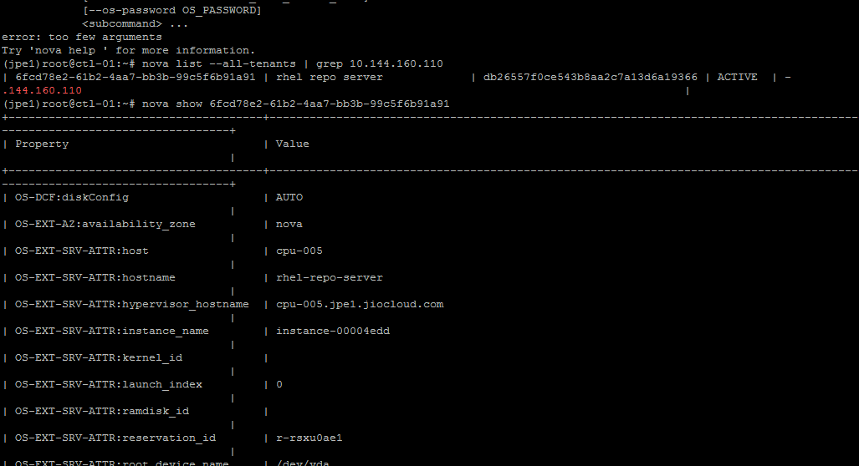

1. nova show 6fcd78e2-61b2-4aa7-bb3b-99c5f6b91a91

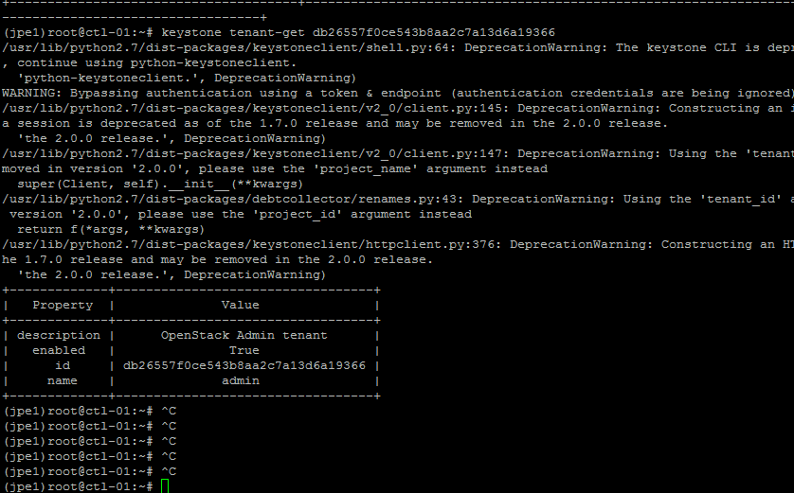

1. keystone tenant-get db26557f0ce543b8aa2c7a13d6a19366